**Format for uploading details in Github and Slack in word file format**

**(Fill this format(docx) daily and upload it in both Github and Slack)**

**Student Name : SURYA PRAKASH S**

**Class and Sec : VI B**

**USN : 4AL17CS101**

|  |  |  |  |  |
| --- | --- | --- | --- | --- |
| **Online Test Details** | | | | |
| **Subject** | **-** | | | |
| **Semester** | **VI -B** | | **Duration** | **-** |
| **% of marks** | | **-** | | |

**Encl : snapshot of the test result**

|  |  |  |  |
| --- | --- | --- | --- |
| **Certification Course Details** | | | |
| **Course** | **DBMS and Cyber Security**  **Webinar on Campus2Corporate** | | |
| **Certificate Provider** | **-** | **Duration** | **04 hours**  **01 hours** |

**Encl : snapshots of the daily class acitivities (atleast two snap shots)**

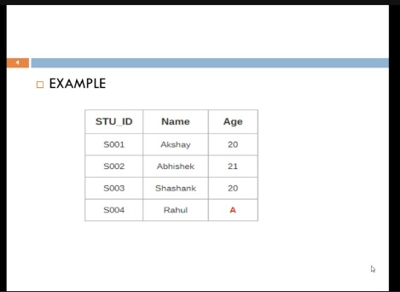

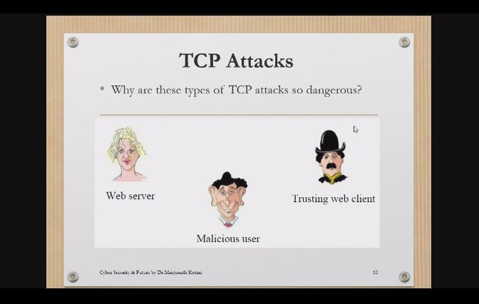

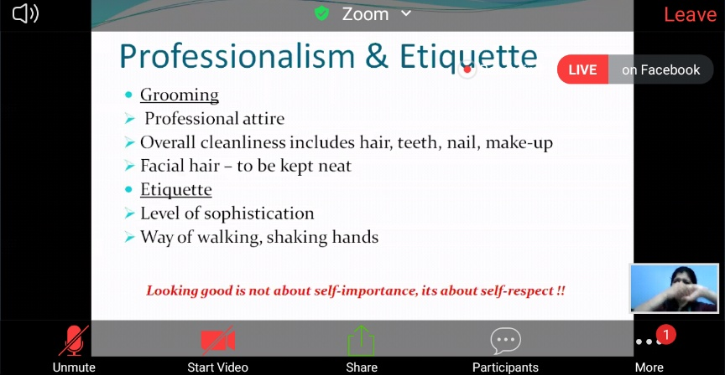

|  |  |
| --- | --- |
| **Coding Challenges** | |
| | **Problem Statement: 1. Python Program to Count the Number of Occurrences of an Element in the Linked List without using Recursions 2. Python Program to Count the Number of Occurrences of an Element in the Linked List using Recursions** | | --- | | |
| **Status: Completed** | |
| **Uploaded the report both in Github & Slack** | **Yes** |

**Encl : snapshots of your response to challenge.**

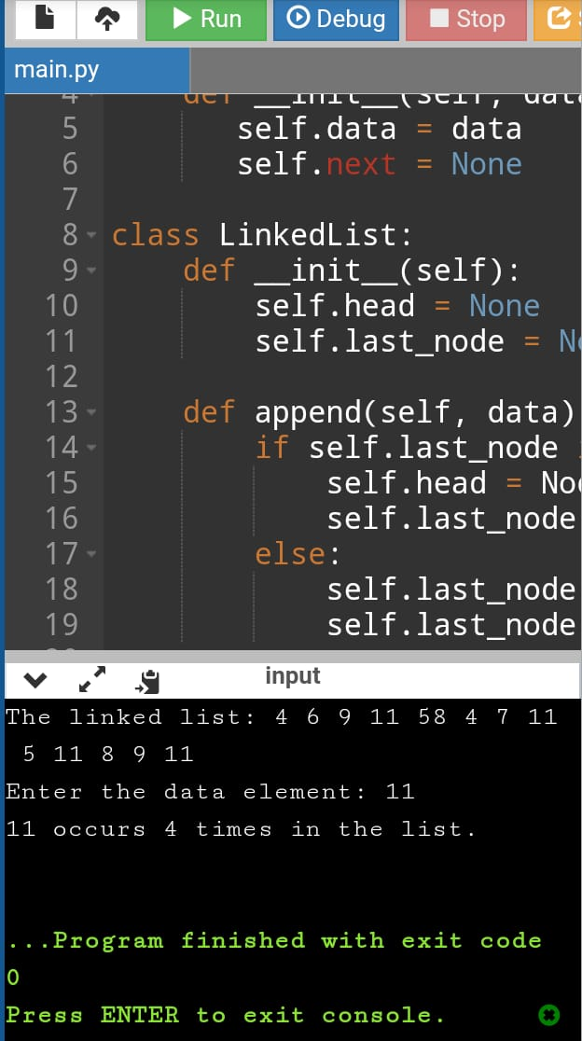

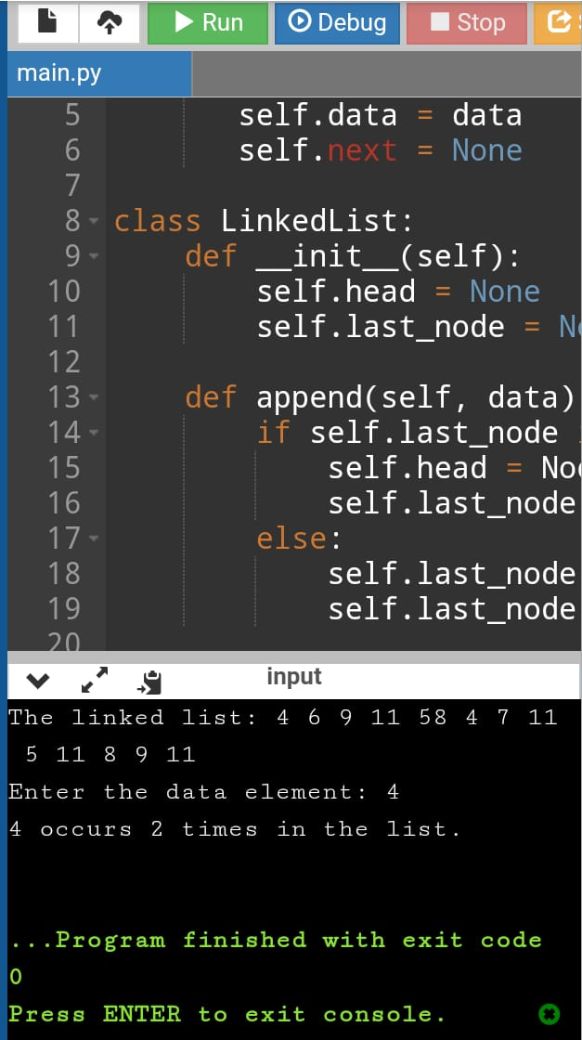

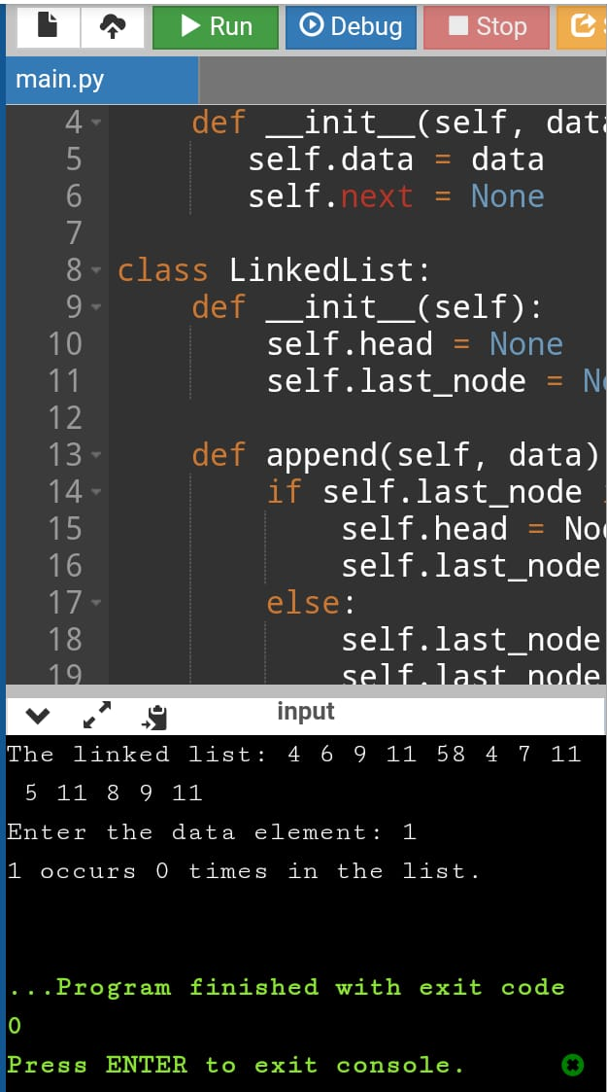

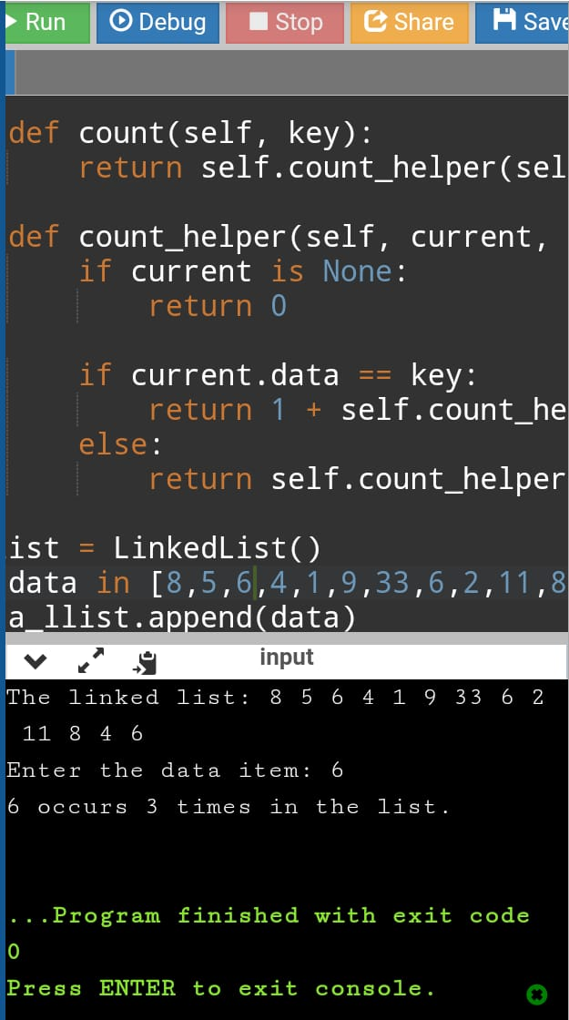

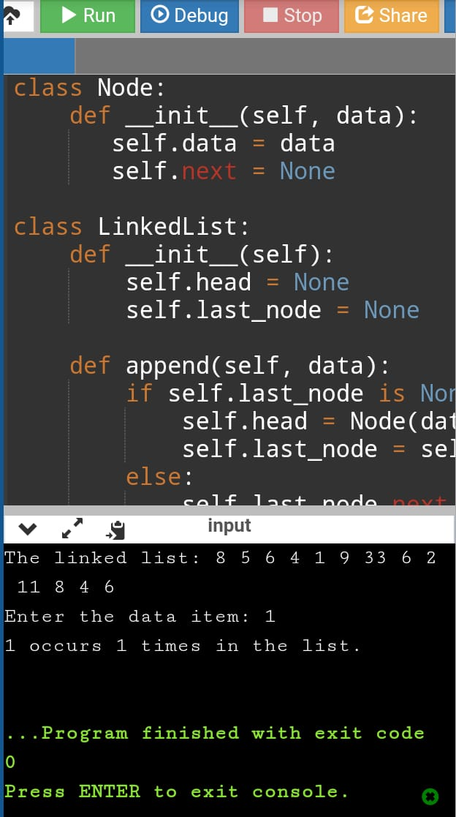

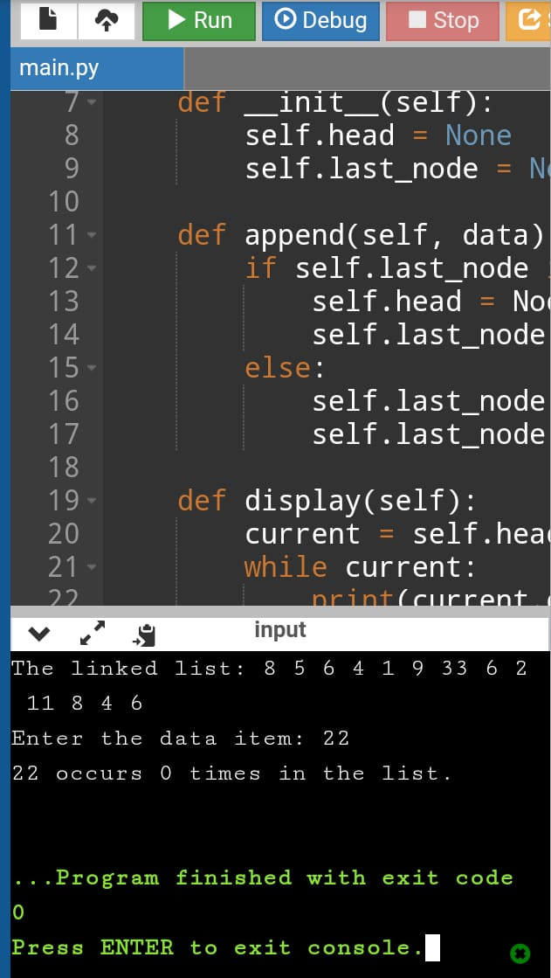

https://github.com/SPSSURYA/Online-Coding-And-Certification-Course